ON THE ACCURACY OF WIND AND WAVE MEASUREMENTS FROM BUOYS
¹Peter K. Taylor, ²Ewa Dunlap, ³F.W. Dobson, ³R. J. Anderson, and ⁴Val R. Swail
ABSTRACT
The reliability and accuracy of wind and wave measurements from moored buoys has been the subject of numerous investigations in the past several years. Most studies were severely hampered by the lack of a suitable data set for comparison. Problems encountered in comparison included some or all of: spatial separation; vastly different platform types, affecting sensor height, flow distortion, platform motion; over-water versus coastal sites.
The Storm Wind Study 2 (SWS-2) was carried out on the Grand Banks of Newfoundland in the winter of 1997-98 using the Canadian research vessel Hudson and a NOMAD meteorological buoy which was specially equipped with several anemometers, wave sensors and a motion sensor, with high data rate recording (2 Hz to 20 Hz). SWS-2 has allowed examination of a number of reported problems affecting buoy winds and waves, including those concerning vector/scalar wind differences, wind fluctuations over waves and wave sensor comparisons.
1.0 INTRODUCTION
The Storm Wind Study 2 (SWS-2) field experiment took place between 29 October 1997 and 15 March 1998. The location of the SWS-2 experiment was the Grand Banks, about 300 km E of St. John’s, near the Hibernia oil field (Figure 1). The project was led by the Climate Research Branch (CRB) of the Meteorological Service of Canada (MSC), with participation of the Southampton Oceanography Centre (SOC; U.K.), BIO, MSC Atlantic and Pacific Regions, and Axys Technologies, the primary Canadian buoy contractor.
The field program comprised a 6m NOMAD buoy, a directional wave rider (DWR) buoy, a Minimet buoy, the Hibernia platform, the Shoemaker semi-submersible platform, and the research vessel CCGS Hudson. Except for Shoemaker (25 km away), and Hudson excursions, all locations are within 1300 m SW of the Hibernia platform. The SWS-2 data are divided into two phases. Phase 1 took place from 29 October 1997 to the date the NOMAD was recovered following mooring failure (12:00 GMT 30 November 1997), and Phase 2 occurring after redeployment on February 19, 1998 until March 15 1998. The NOMAD’s drifting in phase 1 is clearly visible in Figure 1 (right). During the SWS-2 experiment the NOMAD buoy was collecting research type data (logged by the "SWS-2" processor), in addition to the usual operational type data (logged by the "Watchman" processor and transmitted over GOES). The additional (research) payload was designated to gather data (primarily the wind speed and direction, buoy motion, and wave height and period) at 2 Hz and store them without any averaging (Skey et al. 1999).
The Bedford Institute of the Oceanography (BIO) vessel CCGS Hudson was present on site during the period of 17 November to 6 December 1997, i.e. during Phase 1, particularly during two major storm events that occurred on 21 and 26 November as indicated in Figure 1 (left). The high wind and wave conditions present during these storms are shown in Figure 2. This figure depicts the metocean conditions during the SWS-2 field program. There are several notable events, particularly at the beginning of Phase 1, where wind speeds (measured at 5m) reached ~23 m/s, and the significant wave height exceeded 9 m.
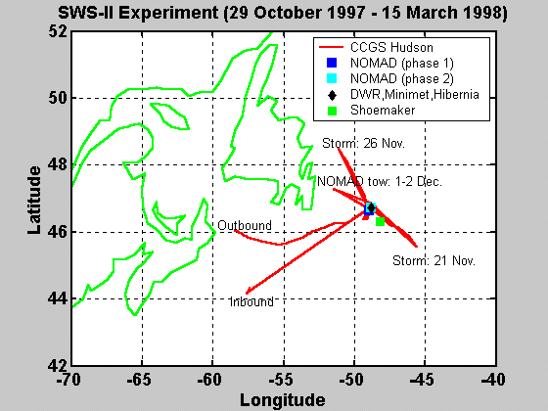
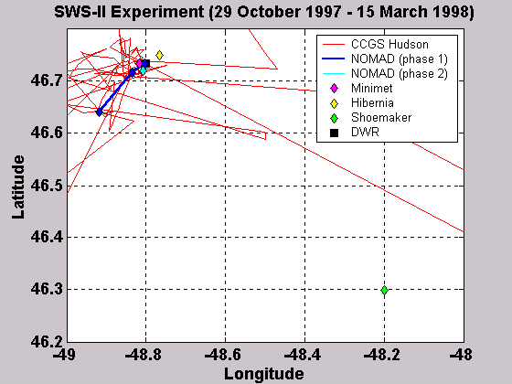

Figure 1. Map showing SWS-II study location and the track of the vessel CCGS Hudson (left) and locations of Hibernia, Shoemaker and BIO/MSC moorings (right)
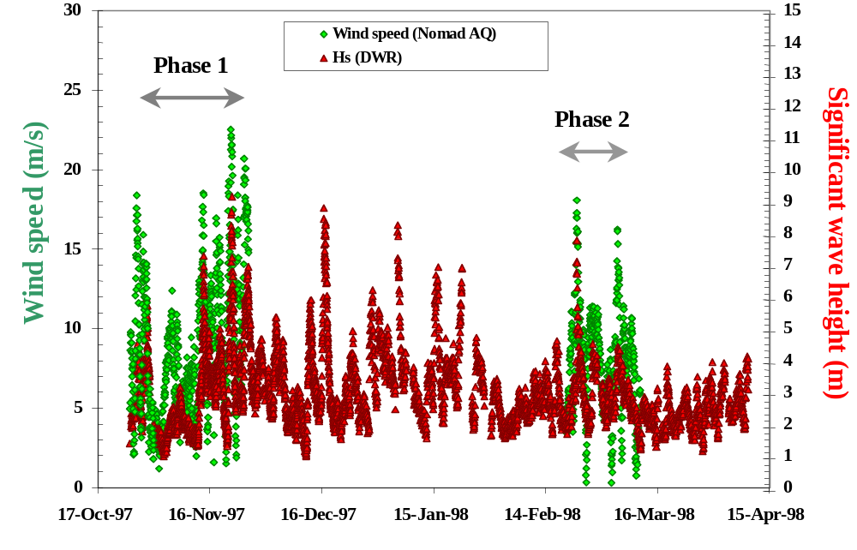
Figure 2. Wind speed and significant wave height for the period of the SWS-2 experiment NOMAD wind and DWR Significant Wave Height
The details of the CCGS Hudson operation are summarized in the Hudson cruise report (Anderson et al., 1998). Data from the Hudson consisted of the standard operational WMO observation (transmitted over the GTS) and the BIO and SOC research data.
Preliminary results from SWS-2 have been described previously (e.g. Blaseckie et al., 1999). A more detailed recent analysis is presented here, in particular the wave sensor comparisons, consideration of the buoy motion, and the use of the HS sonic anemometer data in order to analyze vector/scalar wind differences, and wind fluctuations over waves.
2. DATA SOURCES
There were four anemometers on the NOMAD:
- Two RMY 5106 anemometers mounted on the standard mast aft:
  - AQ quick response (rear RMY at 4.85 m) logged on SWS-2 and SOC processors
  - STD standard (port RMY at 4.45 m) logged on SWS-2 and Watchman (GOES Anemometer 2)
- Two sonic anemometers
  - Gill WM Wind Master sonic logged on SWS-2 and Watchman (GOES Anemometer 1) mounted to starboard on the standard aft mast at 5.5 m
  - Gill research sonic (high-resolution) mounted on a separate mast at the bow and logged at 20Hz on the SOC processor for restricted periods.
There were four wave sensors on the NOMAD, all recorded on the SWS-2 processor:
- Datawell suspended heave sensor (“true” vertical) logged on SWS-2 and Watchman (GOES) processors, located in the central buoy compartment
- Two strap-down accelerometers (“vertical” is always relative to the compartment wall): central (CPT2) and off-center (SWS-2). A strap-down accelerometer is the sensor used operationally on all MSC buoys at this time; previously the Datawell was used in the three west coast NOMADs
- Motion Pak (Systron Donner). The Systron Donner is a 6 degrees of freedom motion sensor, similar to the new Axys/NRC Tri-Axys wave sensor
Other components of the field program included:
- Three bow-mast anemometers on the Hudson, two sonic and one RMY, calibrated and corrected for flow distortion and blocking from the ship:
  - Gill R2A (SOC) at free stream height of 16.42 m
  - Gill R3A (BIO) at free stream height of 16.03 m
  - RMY 5106 AQ (BIO) at free stream height of 16.20 m
- Datawell Directional Waverider (DWR) buoy providing 2-D spectral measurements
The operational data set included the following 10 minute averaged data reported at synoptic times:
- MSC NOMAD buoy (44153) hourly wind, wave, air and sea temperature data logged by the Watchman processor, anemometer height 4.45m
- CCGS Hudson six-hourly wind, wave, air and sea temperature data. Winds conventional from bridge, 26m anemometer height
- Hibernia platform (44145) three-hourly 10 minute means of wind (helideck, 75m), air temperature and wave observations. SST is not included in this data set
- Shoemaker platform (44147) three-hourly 10 minute means of wind (derrick top, 100m), air and sea temperature and wave observations
- BIO Minimet (4755/4756) hourly wind and temperature data (3m anemometer height)
The pictorial representation of some of the measurement platforms is shown in Figure 3.
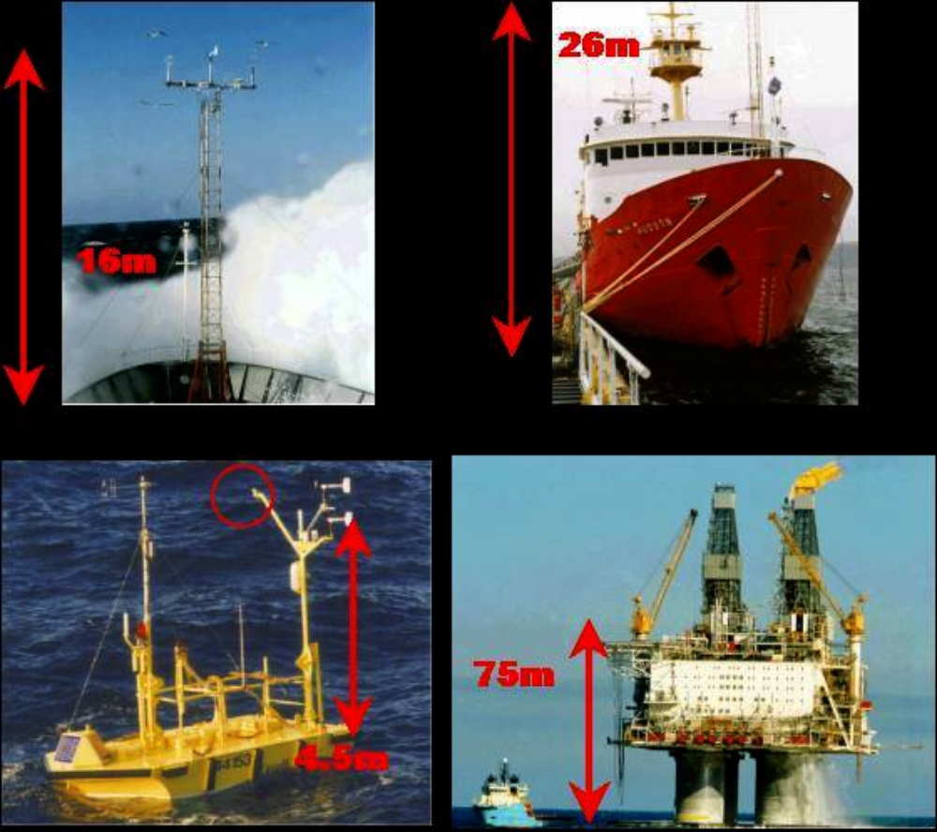
Figure 3. Comparison of the floating platforms geometry and instrument location: Hudson bowmast (top left), CCGS Hudson (top right), NOMAD buoy (bottom left) and Hibernia platform (bottom right).
The NOMAD’s Wind Master sonic anemometer was lost in the early stage of phase 1 (as indicated by in Figure 3 by the circle)
The calibrated BIO bow-mast wind speeds and DWR wave data were used in order to validate the NOMAD buoy measurements. The main objective of the comparison between NOMAD buoy wind and wave data with standard WMO observations is to determine the importance of factors like the effect of the ship structure on the reported operational winds. In general the flow blockage problem on platforms is much greater than on ships due to the platform shape and dimensions, as can be seen in Figure 3. The anemometer heights differ significantly (as indicated schematically in Figure 3) and wind speeds have to be height adjusted prior to any intercomparison.
3.0 ANALYSIS RESULTS
3.1 NOMAD buoy wave data
Validation with BIO data. The NOMAD’s Datawell significant wave height calculated from spectral analysis and transmitted over GOES was compared to the significant wave height values from the DWR buoy calculated using the MLM method. The results are shown in Figure 4 after the removal of two outliers in the DWR data.
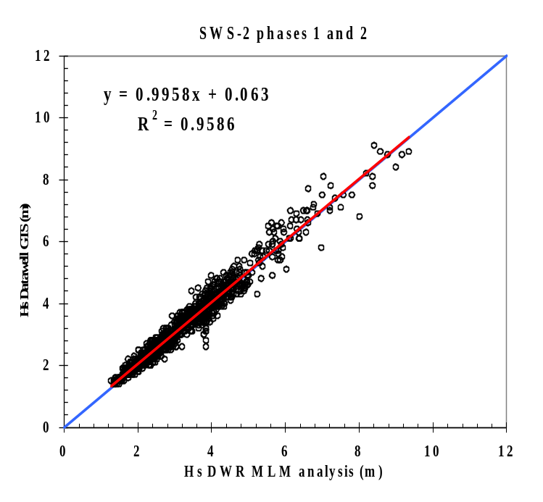
Figure 4. Comparison between the NOMAD Datawell and DWR (MLM analysis) significant wave heights

The DWR would be regarded as a close approximation to “truth” in wave measurement. The NOMAD Datawell compares very well with the DWR, with limited scatter, and a slope of virtually 1. Thus one can conclude that the NOMAD is capable of very good significant wave height measurements.
Sensitivity to accelerometer location. The scatter diagrams of the significant wave heights from the strap-down accelerometers (located in the central, CMPT2, and off-center, SWS-2, compartments) on the Datawell significant wave heights are shown in Figure 5 (Dunlap, 2001).
The noisy scatter in the phase 1 SWS-2 data is due to some spurious data points. The exact reasons for these are not clear, but investigation shows they are clearly spurious and seemingly intermittent. They do not occur in phase 2 when comparison of the strap-down accelerometers versus the Datawell heave sensor shows excellent agreement, with the strap-downs being about 3% lower. There is no apparent difference between the center and off-center accelerometers.
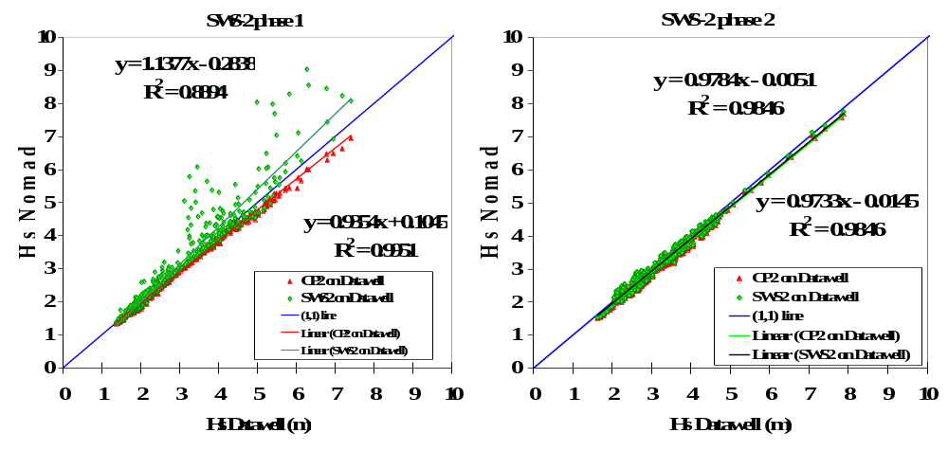
Figure 5. Scatter diagrams for the SWS2 and CMPT2 significant wave heights on NOMAD Datawell significant wave heights for phases 1 (left) and 2 (right)

Historical H_{max} from Buoys. Values of the maximum peak to trough wave height computed from the quality-controlled 2Hz NOMAD Datawell data are compared to the hourly maximum wave height data transmitted over GOES. The corresponding scatter diagram is shown in Figure 6 (Taylor 2001a).

Historically, maximum wave heights were computed as twice the maximum crest height. A true definition would be the maximum successive trough-to-peak difference, which is how maximum waves are now calculated. This plot shows that, on average, the 2x crest value overestimates the actual maximum wave, by about 10% at 15m.

This does not account for other known problems with historical maximum wave estimation, e.g. hitting the upper limits of the voltage ranges (H_{max} would be higher than reported), and strong lateral accelerations which may be interpreted by the sensor as vertical if the buoy itself is not vertical, also leading to erroneous high H_{max} values; this latter problem is more evident in 3m discus buoys than in the NOMAD.

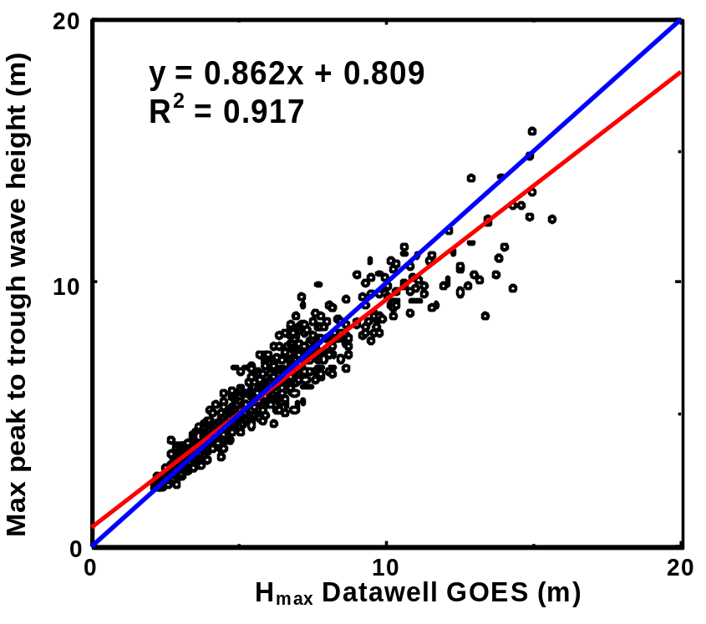
Figure 6. Recomputed Datawell values of the maximum peak to trough wave height for each one hour period compared to the Datawell maximum wave height values transmitted over GOES.
3.2 NOMAD buoy wind data
Vector and Scalar Wind Speed Difference. The comparison between scalar and vector averaged wind speeds from the NOMAD’s AQ RMY anemometer is shown in Figure 7 for the original data (left panel) and data subject to quality control of the direction (right panel). These results are based on the 2Hz NOMAD wind data (Taylor, 2001a).
The left-hand panel shows the scalar wind speed to be 6-7% higher than the vector wind, with considerable scatter; individual errors in vector speed may be as much as 50%. Detailed investigation reveals that this is almost all due to problems with the orientation of the RMY potentiometer dead band towards the bow, i.e. usually into the wind. This causes wild fluctuations in the reported wind direction, which serves to reduce the vector wind speed. When the erroneous wind directions are removed, the right panel shows a close fit, where NOMAD vector average is about 1% lower than scalar increasing to 2% at 20m/s.
Thus, while the vector averaged wind speed is expected to be closer to the correct value, the scalar wind provides a more robust wind estimate than the vector averaged wind speed in any situation where errors may occur in the wind direction values. Such errors could lead to serious underestimates in the vector averages. The residual difference in the quality controlled data (Figure 7, right panel) is most likely caused by cross-wind movement of the buoy in response to waves. This results in a small, high bias in the scalar averaged values. For quality controlled ship’s data the difference is less than 1% (Taylor, 2001b).

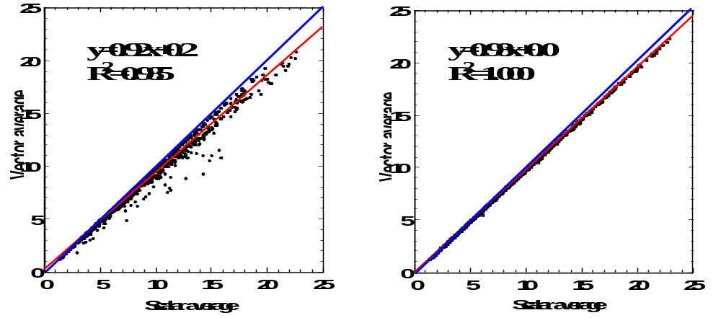
Figure 7. Comparison of vector and scalar averages for the AQ (RMY Back) for the original data set (left) and after quality control of the direction and compass data (right).

Comparison with the bow mast winds. The NOMAD’s wind speeds were compared with the bow-mast winds during times when the Hudson was within 20 km of the buoy. The bow-mast data are quality controlled and are corrected for the flow distortion and blockage factors. Bow-mast wind speeds were adjusted to NOMAD anemometer heights using Walmsley’s method (Walmsley 1987) and SOC air temperatures (AT) from the bow-mast and SOC SST data. The NOMAD’s RMY wind speeds logged by the SWS-2 processor were used in this analysis. The STD RMY (Port) anemometer had an AQ propeller and was corrected for calibration error. All RMY winds are scalar winds, however the BIO bow-mast Gill R3A sonic was logged as vector winds. The corresponding scatter diagrams are shown in Figure 8.
The bow-mast winds, calibrated and corrected, are probably the closest we can come to “true” winds. Irrespective of which of the NOMAD or bowmast anemometer pairs are used, the buoy does very well, although still ~2-3% low.

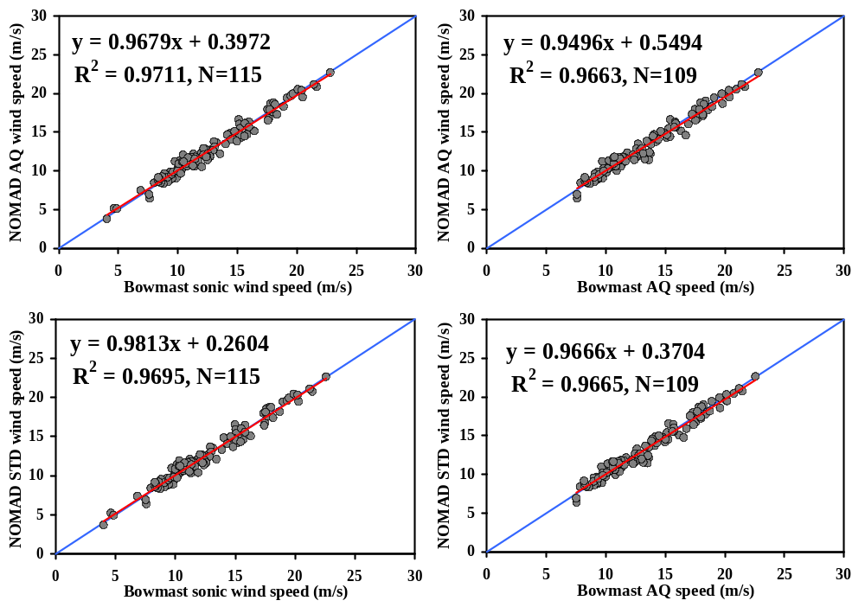
Figure 8 Scatter diagram of AQ5305 (top) and STD5103/6 (bottom) scalar wind speeds on BIO Gill R3A vector sonic (left) and BIO RMY (AQ) Wind Master scalar (right) wind speeds

Wind Fluctuation Over Waves. The top graph in Figure 9 shows the observed wind speed (dark blue line, left scale) averaged as a function of wave phase and repeated for two periods for ease of viewing. The grey line is the buoy heave (right hand side scale). Variations in the wind speed are about 3 m/s, or 13% in this high wave case. Overall, the variations are less than 10% (Taylor, 2001b). The middle plot is the same but for the platform speed. This shows significant variations in platform speed, in the same phase as the wind speed variations. The bottom plot is for the wind speed corrected for platform motion. The residual variations are likely insignificant, within the observing error.
These preliminary results suggest that there is no significant sheltering of the wind sensors due to the waves, e.g. the 10-minute mean wind speeds, as reported by the buoy, will be similar to those calculated after motion correction although the standard deviation will be higher.
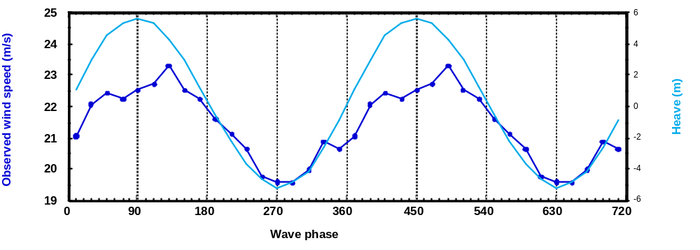
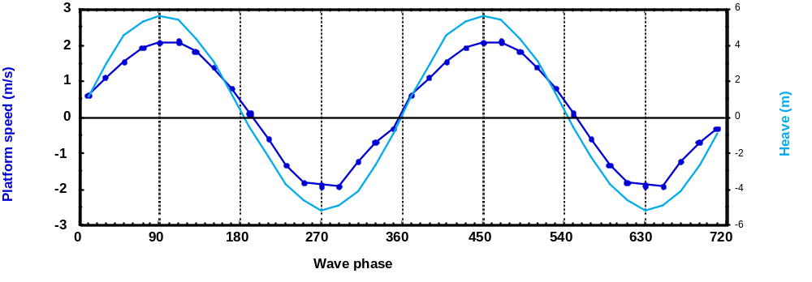
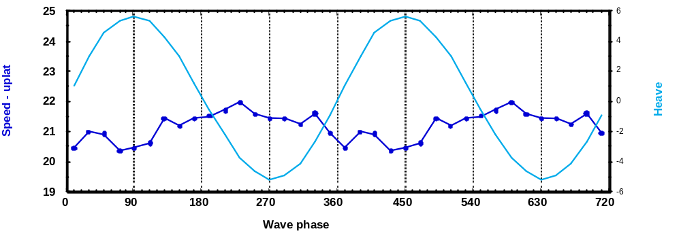

Figure 9. The averaged observed wind speed (top), the platform speed where forward (into the wind) is positive (middle) and the wind speed corrected for platform motion (bottom). The grey line on each plot is the buoy heave (right scale).
4.0 OPERATIONAL DATA COMPARISONS:
Operational data are routinely transmitted to National Oceanic and Atmospheric Administration (NOAA) Geostationary Operational Environmental Satellites (GOES) and Polar Orbiting Environmental Satellites (POES) of the ARGOS system. The GOES messages are sent to the NOAA National Environmental Satellite, Data, and Information System (NESDIS) at Wallop's Island. The message in RAW format is then named with the header, (e.g. SXVX42 KWAL), and put on the Global Telecommunication System (GTS). If the GOES transmitter fails, the ARGOS (backup) message is sent over the GTS.
Wind speed comparison. Scatter diagrams of the operational wind speeds from Hibernia versus the NOMAD STD RMY are shown in Figure 10. Scatter diagrams of the operational wind speeds from Minimet, Shoemaker and Hudson versus the NOMAD STD RMY are shown in Figure 11. The comparison is made both before and after the height adjustment in order to show the effect of height adjustment on the wind speed. Operational wind data are not corrected for blockage and flow distortion.
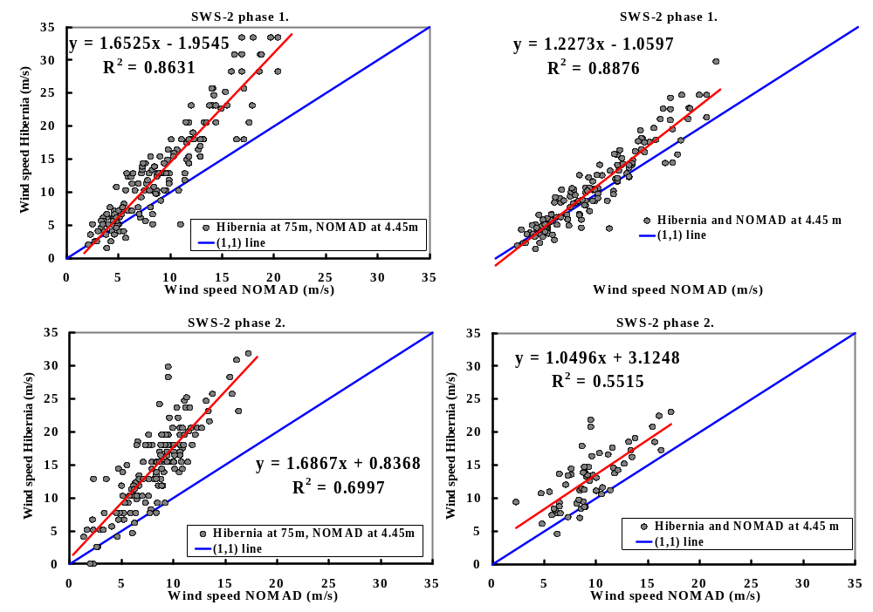
Figure 10 Scatter diagram of the Hibernia on NOMAD GTS wind speed for phase 1 (top) and 2 (bottom) for Hibernia data at 75 m (left) and adjusted to NOMAD’s height (right)
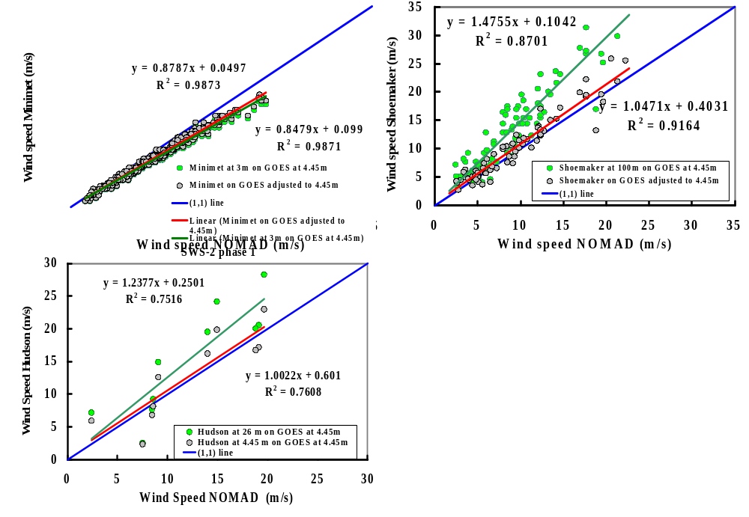
Figure 11 Scatter diagram of the wind speed for Minimet (top left) Shoemaker (top right) and Hudson WMO (bottom left) on NOMAD GTS wind speeds.
The unadjusted Hibernia platform data (Figure 10) clearly show the effects of elevation differences. However, the phase 1 adjusted winds still show a large residual difference, which may be due to flow distortion effects around the helideck on this very large platform. The residual difference for the phase 2 data appears even larger but it is not obvious that the difference from the phase 1 data is significant given the expected large variation in the air flow distortion with varying relative wind direction.
The height-adjusted Minimet wind speeds were consistently too low by 15-20% compared to the NOMAD (Figure 11). The Minimet was observed to be heeling over in any wind, and this may explain why the speeds were low, although the correlation is quite high, suggesting that the Minimet’s winds could be corrected to match the NOMAD.
The Shoemaker is a semi-submersible with the anemometer at the top of the derrick. Again the effects of elevation are clearly seen. However, reduction to 4.45 m gives good average agreement. This suggests that the anemometer suffered less from flow distortion compared to the Hibernia instrument and that the scatter was due to the 25km separation of the platforms.
Significant wave height comparison. Scatter diagrams of the operational significant wave heights from Hibernia (phases 1 and 2), Shoemaker and Hudson versus the NOMAD Datawell are shown in Figure 12.
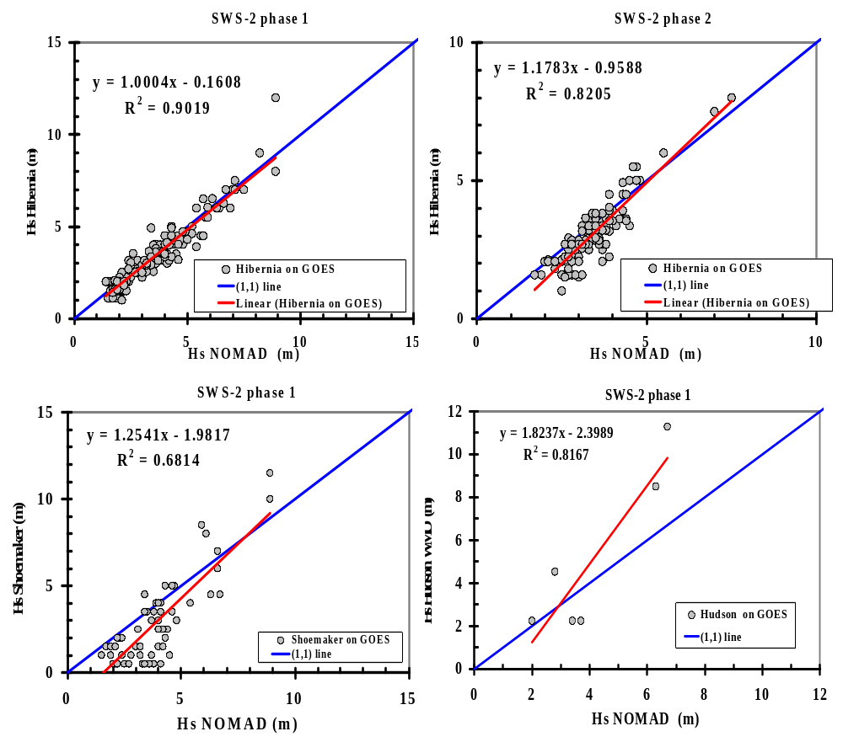
Figure 12. Scatter diagram of the significant wave heights for Hibernia (top), Shoemaker (bottom left) and Hudson WMO observations (bottom right) on NOMAD Datawell Hs.
Phase 1 results show good agreement between NOMAD and Hibernia significant wave heights. However it is not known how the operational phase 1 data were obtained, since the data set of MIROS data, that was available to this study, only start in late December (Dobson and Dunlap, 1999). Indeed subsequent information suggests that the early Hibernia wave heights were obtained from the NOMAD transmissions, hence the excellent agreement! If so the scatter merely represents the coarser precision of the operational data (0.5m). Phase 2 results, when the MIROS sensor was in operation, show poorer agreement with waves below 5m tending to be underestimated in the operational data.
The Shoemaker reported only waves (no swell). The data source is unknown and clearly biased low for wave with Hs less than 5m and high for waves with the Hs greater than 5m. The Hudson operational wave reports were too few to draw a clear conclusion.
- CONCLUSIONS
The following conclusions can be made based on the presented results:
(a) NOMAD Waves:
- NOMAD Datawell agrees well with DWR
- Strap-down accelerometers generally underestimate Hs by 2-5%, but may also be unpredictable in some situations
- Accelerometers are generally not sensitive to location, but better to mount centrally
- Historical H_{max} biased high overall
(b) Vector-Scalar Winds:
- Vector averages are affected by any wind direction errors
- Mount RMY anemometers with 0º pointing towards the aft
- NOMAD vector average is about 1% lower than scalar increasing to 2% at 20m/s for QC data – may be 10 - 50% otherwise
- For ship’s data the Vector scalar difference is less than 1%
(c) Wind Fluctuations Over Waves:
- Preliminary results
- For the case studied (2 periods) overall wind fluctuation with waves is less than 10%
- Residual variation of wind speed corrected for buoy motion is likely insignificant, within the measurement error.
(d) Wind: NOMAD vs “truth”
- Calibrated bowmast winds represent the closest thing to “truth” in marine winds
- Properly calibrated buoy and bowmast anemometers are in good agreement (buoy about 2-3% low at 20 m/s)
(e) Wind: Operational Data
- Effects of blockage and flow distortion may be large
- Metadata are required including e.g. instrument types, location, instrument history
Overall, the operational reliability of wind and wave measurements from moored buoys is quite good with the exception of some measurements using the sonic anemometers (spiking due to ice accretion, drizzle, fog and wet snow) and moorings. The accuracy of the quality controlled wind and wave data from buoys are better than expected. Future comparisons between buoys and the forthcoming consistently-instrumented VOS-Clim ships will be useful.

Acknowledgments. This work was funded by the Canadian federal Program of Energy Research and Development (PERD). The Hibernia platform staff assisted in a number of ways, including the provision of space on the platform for telemetry receivers and recording systems for the buoys, and the archiving of the DWR telemetry data. We acknowledge the professional assistance of the Captain and crew of CCGS Hudson in deploying and recovering the DWR buoy, and recovery of the NOMAD. We would also like to acknowledge the significant contributions of the Canadian buoy specialists, notably Mike McNeil and Ron McLaren, the latter who made available the NOMAD buoy for the field program.
6.0 REFERENCES
Anderson, R.J., F.W. Dobson, Y. Geshelin, A.J. Hartling, R. Pascal, and P.K. Taylor, (1998). Cruise Report: Hudson 97-069. Bedford Institute of the Oceanography, Dartmouth, NS, Canada.
Blaseckie, M., S. Skey, K. Berger-North, V. Swail and R. McLaren, (1999). The Storm Wind Studies – an investigation into the data recovered from a 6m moored NOMAD buoy on Canada’s east and west coasts. Proc. Data Buoy Cooperation Panel Technical Workshop, October, 1999, Wellington, NZ, p. 79-89.
Dobson, F. and E. Dunlap, (1999). Miros system evaluation during storm wind study II. Proc. of CLIMAR 99 WMO Workshop on Advances in Marine Climatology, Vancouver, 8-15 September 1999, 98-109.
Dunlap, Ewa, (2001). Statistical Analysis Of Storm Wind Study (SWS-2) Wind And Wave Measurements. Weathervane Scientific Inc. Halifax. NS, Canada. Report EMD2000_04.
Skey, Simon G.P., Kent Berger-North, Val Swail and Andrew Cornett (1999). The Storm Wind Studies (SWS). Proc. of CLIMAR 99 WMO Workshop on Advances in Marine Climatology, Vancouver, 8-15 September 1999, 69-78.
Taylor, Peter K., (2001a). Summary of Progress on SWS-2 Analysis. SOC Draft Report, April 2001.
Taylor, Peter K., (2001b). SOC. Personal Communications.
Walmsley J. L., (1987). On theoretical wind speed and temperature profiles over the sea with applications to data from Sable Island, Nova Scotia., Atmosphere-Ocean 26, 203-233.

¹ Southampton Oceanography Centre, Southampton, UK ² Weathervane Scientific Inc., Halifax, Nova Scotia ³ Fisheries and Oceans Canada, Bedford Institute of Oceanography, Dartmouth, Nova Scotia ⁴ Meteorological Service of Canada, Downsview, Ontario
1 All data on the SWS-2 processor were recorded at 2 Hz.

